Lab Manual
Practical and Skills Development

CERTIFICATE

THE ASSIGNMENT ENTERED IN THIS REPORT HAVE BEEN SATISFACTORILY PERFORMED BY

Registration No | :25BHI10125
Name of Student | :AYUSH SAXENA
Course Name | : Introduction to Problem Solving and Programming
Course Code | : CSE1021
School Name | : School of Computing Science
Engineering and Artificial Intelligence (SCAI)
Slot : B11+B12+B13
Class ID : BL2025260100796
Semester : FALL 2025/26

Course Faculty Name : Dr. Hemraj S. Lamkuche

Signature:

Practical Index
S. No. | Title of Practical | Date of Submission | Signature of Faculty
1 | aliquot_sum(n) Function | 16/11/20225
2 | are_amicable(a, b) Function | 16/11/20225
3 | multiplicative_persistence(n) function | 16/11/20225
4 | is_highly_composite(n) Function | 16/11/20225
5 | mod_exp(base, exponent,modulus) function | 16/11/20225

1
10/11/2025

TITLE: Write a function Lucas Numbers
Generator lucas_sequence(n) that generates the first n Lucas numbers (similar to Fibonacci but starts with 2,
1).

AIM/OBJECTIVE(s): lucas_sequence

METHODOLOGY & TOOL USED:

Python programming language

BRIEF DESCRIPTION:
A generator function (lucas_sequence) is implemented to yield Lucas numbers iteratively, which is memory-efficient. The main part of the script calls this generator, collects all generated numbers into a list, and measures the performance of this operation.

RESULTS ACHIEVED:
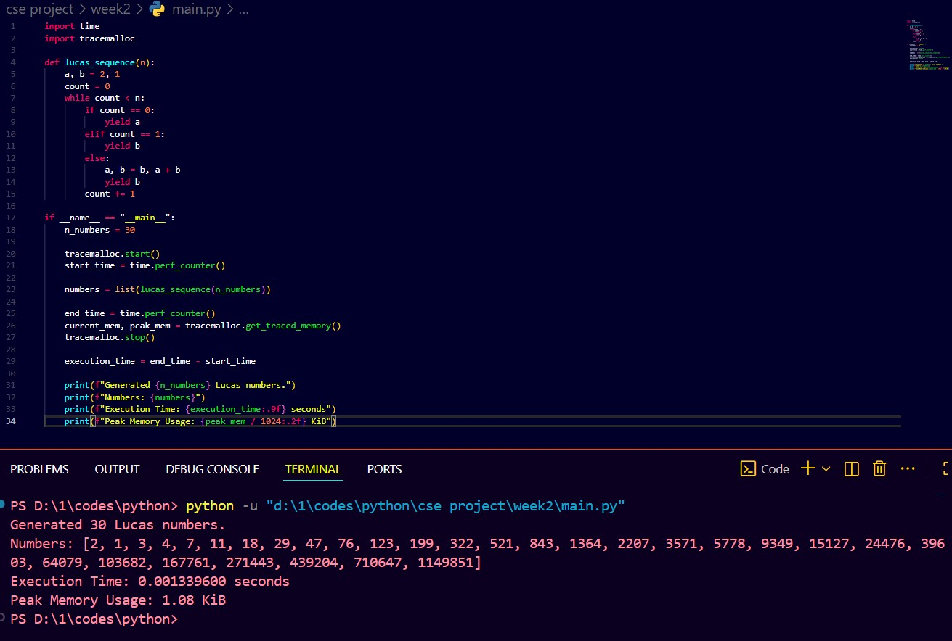

SKILLS ACHIEVED:
- Python programming fundamentals.
- Implementation of generator functions (using yield) for efficient data generation.
- Performance analysis:
○ Measuring code execution time using the time module.
○ Measuring peak memory usage using the tracemalloc module.
- Understanding and using the if __name__ == "__main__":
guard.
- Using formatted strings (f-strings) for clear and dynamic output.

2
16/11/2025

TITLE: Perfect Power Check with Performance Measurement

AIM/OBJECTIVE(s):To write a Python function is_perfect_power(n) that determines if a given integer n can be expressed as $a^b$, where $a > 0$ and $b > 1$. The script should also measure the execution time and peak memory usage of this check.

METHODOLOGY & TOOL USED:Python programming language

BRIEF DESCRIPTION:
is_perfect_power(n). It first handles edge cases where $n \le 3$. It then iterates through potential bases a from 2 up to int(math.sqrt(n)) + 1. For each a, it enters a nested loop for exponent b (starting at 2). It calculates $a^b$ in each step. If $a^b == n$, it returns True. If $a^b > n$, it breaks the inner loop and tries the next base a. If no such pair (a, b) is found after all checks, it returns False.
The main execution block measures the time and memory for checking two numbers (one perfect power like 125, and one non-perfect power like 126) and prints the results.

Result:
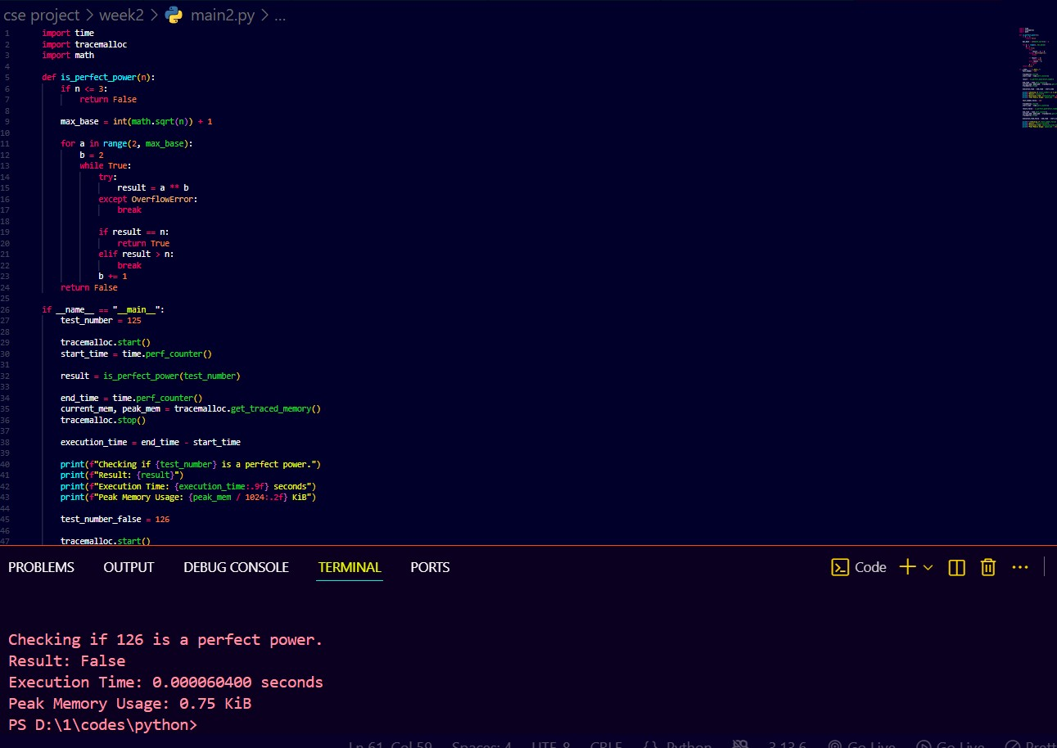

SKILLS ACHIEVED:
The script successfully checks if the test numbers are perfect powers and reports the performance.

3
16/11/2025

TITLE:Write a function Collatz Sequence
Length collatz_length(n) that returns the number of steps for n to reach 1 in the Collatz conjecture.

AIM/OBJECTIVE(s):To write a Python function collatz_length(n) that returns the number of steps required for a given integer n to reach 1 by following the rules of the Collatz conjecture .

METHODOLOGY & TOOL USED
Python programming language

BRIEF DESCRIPTION:
The code defines a function collatz_length(n) that calculates the
"stopping time" for the Collatz sequence starting at n

RESULTS ACHIEVED:
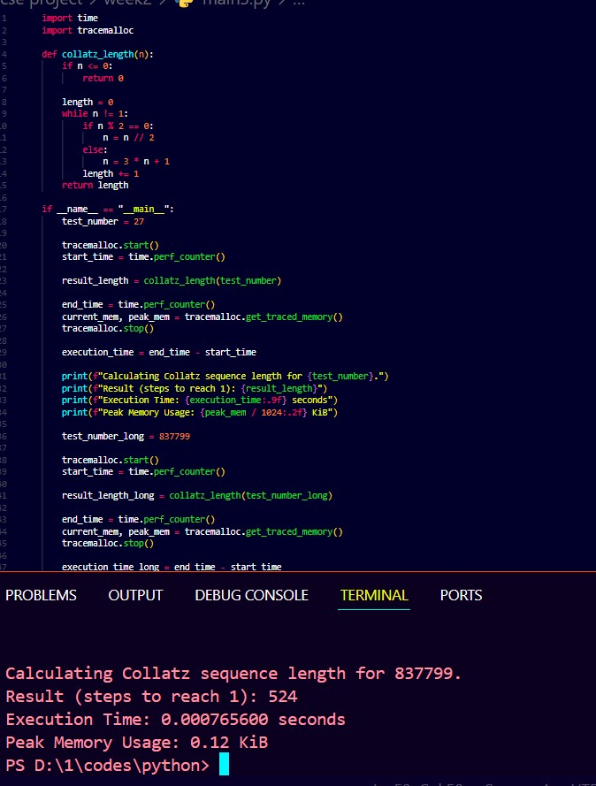

SKILLS ACHIEVED:
Implementation of an iterative algorithm based on a mathematical conjecture.
Use of conditional logic (if/else) and loop structures (while).
Integer arithmetic (using % for modulus and // for integer division).
Continued practice in performance analysis with time and tracemalloc.

Practical No: 4
Date: 16/11/2025

TITLE:Write a function Polygonal Numbers polygonal_number(s,
n) that returns the n-th s-gonal number.

AIM/OBJECTIVE(s) : To write a Python function polygonal_number(s, n) that calculates and returns the n-th s-gonal (polygonal) number, given the number of sides s and the term n. The script should also measure the execution time and peak memory usage.

METHODOLOGY & TOOL USED:
Python programming language

BRIEF DESCRIPTION :

The code defines a function polygonal_number(s, n) that implements the mathematical formula for the n-th s-gonal number. It includes a check to ensure s (sides) is at least 3 and n (term) is at least 1.
The main execution block (if __name__ == "__main__":) measures the time and memory for calculating two different polygonal numbers:
- The 10th pentagonal (5-gonal) number.
- The 12th triangular (3-gonal) number.
It prints the calculated number, the execution time, and the peak memory usage for each case.

Result:
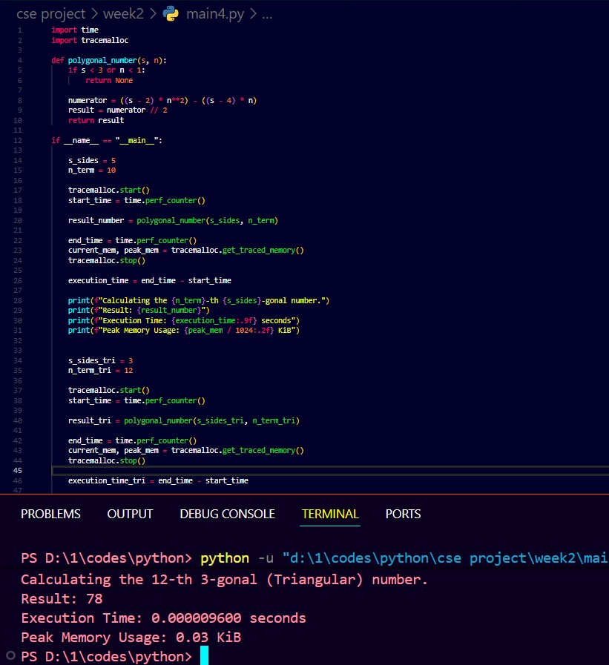
SKILLS ACHIEVED :
- Translation of a mathematical formula into a working Python function.
- Handling function arguments and basic input validation (e.g., $s \ge 3$).
- Continued practice in performance measurement with time and tracemalloc.
- Testing the function with known values (e.g., triangular, pentagonal numbers) to verify correctness

Practical No: 5
Date: 16/11/2025

TITLE:Write a function Carmichael Number
Check is_carmichael(n) that checks if a composite number n satisfies an−1 ≡ 1 mod n for all a coprime to n.

AIM/OBJECTIVE(s):
To write a Python function is_carmichael(n) that checks if a given composite number n is a Carmichael number. A number is a Carmichael number if it is composite and satisfies $a^{n-1} \equiv 1 \pmod n$ for all integers a that are coprime to n.

METHODOLOGY & TOOL USED:Python programming language

BRIEF DESCRIPTION:
The code defines two functions. is_prime(n) is a standard trial division primality test. is_carmichael(n) implements the definition of a
Carmichael number. It first rules out prime numbers. Then, it iterates through all possible bases a from 2 to $n-1$, finds those coprime to n, and tests if $a^{n-1} \pmod n$ is 1.

RESULT:
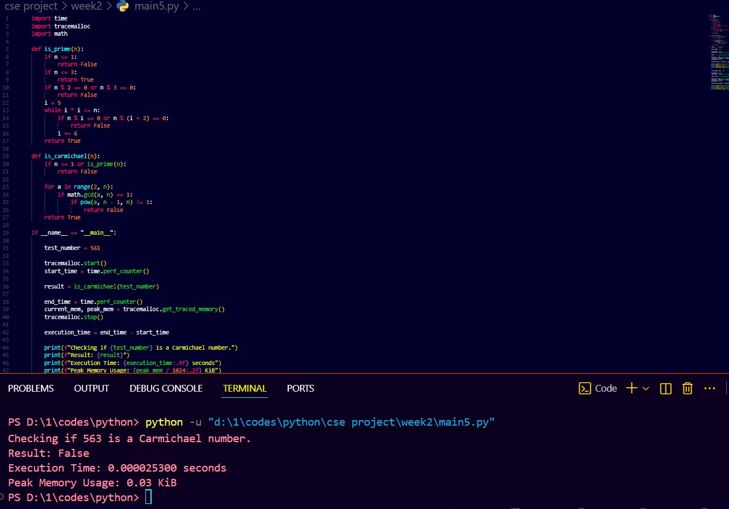

SKILLS ACHIEVED:

Implementation of number theory definitions (Primality, Coprimality, Fermat's Little Theorem).
- Use of helper functions (is_prime) to structure complex logic.
- Use of math.gcd for coprimality testing.
- Use of pow(a, b, m) for efficient modular exponentiation.
- Understanding the computational cost of different algorithms.

